**NEWS APP**

Project Design Phase-II Data Flow Diagram & User Stories

|  |  |
| --- | --- |
| **Date** | **22nd November 2023** |
| **Team ID** |  |
| **Project Name** | **An Android Application for keeping up with latest headlines** |
| **Maximum Marks** | **4 marks** |

Data Flow Diagram

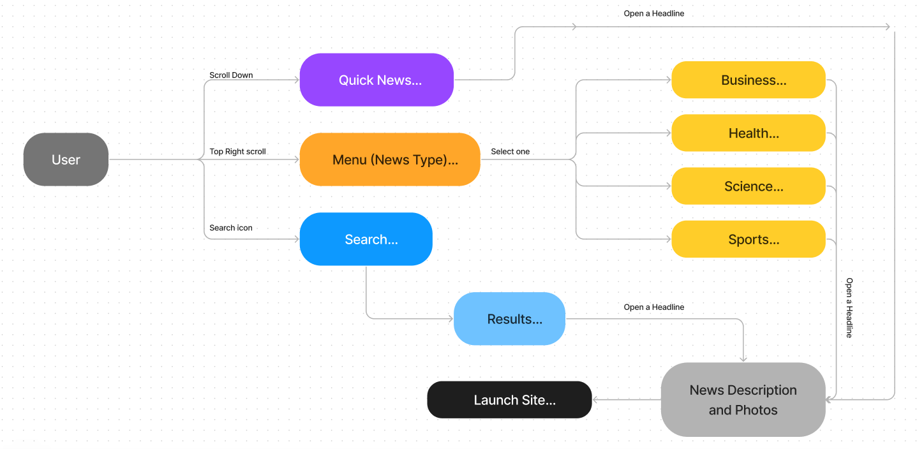

User Stories

|  |  |  |  |  |  |  |
| --- | --- | --- | --- | --- | --- | --- |
| **User Type** | **Functional Requirement (Epic)** | **User Story Number** | **User Story / Task** | **Acceptance criteria** | **Priority** | **Release** |
| Android User | Homepage | USN-1 | I can scroll through the latest news feed headlines. | I can see latest news | High | Sprint-1 |
|  |  | USN-2 | I can open a headline which will give me summary of the headline with photos | Expand headline | High | Sprint-1 |
|  |  | USN-3 | To know more about the news, I can click further to reach to the website | Go to website | Low | Sprint-2 |
|  | Search | USN-4 | To Search for headlines related to a topic | To search | High | Sprint-1 |
|  |  | USN-5 | When searched, the news part will show headlines | To search | High | Sprint-1 |
|  | Menu | USN-6 | We can scroll through the menu of type of news (Which includes – Business, Health, Science,  Sports, Technology, etc) | To navigate through the types of news | High | Sprint-1 |